# **10 Reasons Why a BPO for Customer Support Can Transform Your Business**

In today's competitive and increasingly globalized business landscape, executives constantly seek solutions to optimize operations, cut costs, and boost customer satisfaction. As strategic decision-makers, it's crucial to explore every avenue that can drive transformation and growth. One such opportunity lies in outsourcing customer support to a Business Process Outsourcing (BPO) provider.

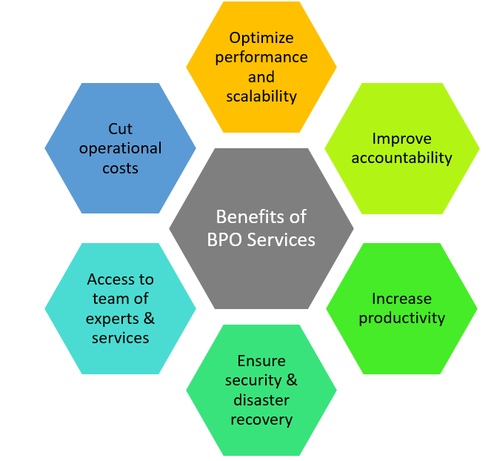

[Source](https://oworkers.com/wp-content/uploads/2022/01/benefits_of_Business_Process_Outsourcing_services.png)

In this article, we will discuss the ten compelling reasons to consider this strategic move for your organization.

## **1: Cost-Efficiency**

One of the primary factors drawing the attention of numerous executives towards Business Process Outsourcing (BPO) is its considerable cost savings. BPO providers frequently set up their operations in regions where labor expenses are significantly lower, a fact that results in substantial direct savings for your organization.

It's not merely the reduction in labor costs that prove to be advantageous. When you engage a BPO provider, you also sidestep the need to invest heavily in various related costs. These include the expense of training new employees, the cost of providing benefits to in-house staff, and the considerable financial commitment involved in setting up and maintaining the infrastructure necessary for a full-scale, in-house customer service department.

In fact, the financial benefits of BPO can be more substantial than you might initially expect. A report by Deloitte, a recognized authority in the field of business analysis, has suggested that organizations can realize operational cost savings of up to 60% through the adoption of BPO. This represents a significant saving that can profoundly impact an organization's finances.

What makes this potential saving even more compelling is the opportunities it presents for reinvestment. The funds that you save through BPO can be strategically channeled back into the essential areas of your business. This might include bolstering your product development department, enhancing your marketing efforts, or investing in employee development programs. The reinvestment of these savings can stimulate your organization's transformation and growth.

## **2: Focus on Core Competencies**

Every business, regardless of size or sector, possesses its unique set of core competencies. These competencies, or specialized capabilities, set the organization apart from its competitors and grant it an edge within the marketplace. These might be superior product development capabilities, an exceptionally talented strategic planning team, or a uniquely innovative marketing department that knows how to effectively connect with the target audience.

When a company decides to outsource its customer support functions, it avails itself of the opportunity to channel more resources, be it time, manpower, or capital, towards these critical areas of competency. This strategic decision allows your business to delve deeper into what it does best and where its competitive advantage lies.

For instance, if your business excels at product development, outsourcing customer support means your team can devote more time and energy into creating, testing, and refining new products. If strategic planning is your forte, your executives can spend more time mapping out the future of your business and responding to market trends without the constant distraction of customer support issues.

Similarly, if your business thrives on innovative marketing campaigns, the marketers in your team can have more freedom to brainstorm, strategize, and execute their creative ideas. They can focus more on building your brand and connecting with your customers, rather than getting entangled in support tasks.

This concentrated focus on core competencies tends to result in an acceleration of innovation within these key areas. As your team members are granted the time and resources to explore, innovate, and hone their skills, your business is likely to see a surge in creativity, productivity, and efficiency. This amplified focus can translate into tangible business growth, propelling your organization towards its strategic goals

## **3: Access to Expertise and Advanced Technologies**

By choosing to engage with a Business Process Outsourcing (BPO) provider, your organization can tap into a rich reservoir of expert knowledge and pioneering technology. This is one of the most potent advantages of outsourcing - you are no longer confined to the in-house capabilities or the technology currently at your disposal. Instead, you gain entry into a broader world where specialized expertise and technological innovation are the norm.

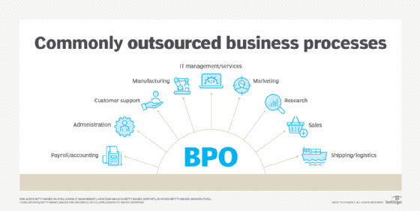

[Source](https://cdn.ttgtmedia.com/rms/onlineimages/commonly_outsourced_business_processes-f_mobile.png)

BPO providers, by the very nature of their work, are masters in their field. They are on the frontlines of customer service, dealing with a vast array of industries and consumer issues, and honing their skills daily. This continual practice and exposure allow them to become adept at handling a wide variety of customer interactions and scenarios. Their professional development is dedicated to customer service excellence, which is a significant advantage that they bring to your organization.

Not only do they bring people expertise, but these BPO firms also utilize the latest technologies to deliver their services. In today's rapidly evolving tech landscape, innovations such as Artificial Intelligence (AI) and machine learning are revolutionizing customer support, enabling more efficient service, personalized interactions, and improved customer satisfaction. These technologies allow for the automation of repetitive tasks, the prediction of customer behavior, and the provision of 24/7 support – all contributing to a superior customer experience.

## **4: Scalability and Flexibility**

The business landscape of today is marked by its dynamism, where market demands can oscillate swiftly and often unpredictably. As an executive in the midst of this ever-changing environment, one of your primary responsibilities is to ensure your organization remains agile, able to nimbly navigate these fluctuations and adapt operations swiftly in response to changing needs. A solution that is increasingly gaining traction among businesses to address this requirement is Business Process Outsourcing (BPO).

BPO is not just a way to offload certain operational tasks; it's a strategic tool that grants your organization the ability to scale up or down with speed and efficiency. With a BPO provider, your customer support operations can become a flexible part of your business model, rather than a fixed structure that's hard to change. You gain the ability to modify the size and capacity of your customer support team according to the ebb and flow of market demands.

In a business environment characterized by volatility and rapid shifts, the adaptability offered by BPO isn't just an asset – it's a necessity. By entrusting your customer support operations to a reliable BPO provider, you're equipping your organization with the ability to ride the waves of market demand with resilience and agility, ensuring that you not only survive the fluctuations but also seize them as opportunities for growth.

## **5: Improved Customer Satisfaction and Retention**

In the world of business, there's a universal truth that's held across sectors and geographies - the satisfaction of customers forms the bedrock of a company's success. When customers are satisfied, they tend to stay loyal, make repeat purchases, and often become brand advocates, recommending your products or services to others. This is where Business Process Outsourcing (BPO) can play a crucial role. By outsourcing your customer support to a BPO provider, you can significantly augment your customer service capabilities, leading to enhanced customer satisfaction and loyalty.

BPO providers are professionals specializing in delivering exceptional customer service. They bring to the table tried-and-tested systems, advanced technology, and a team of trained professionals who know how to effectively and efficiently handle customer inquiries and issues. This combination results in a superior level of customer service, where queries are addressed promptly, problems are resolved quickly, and customers feel valued and understood..

## **6: Broadened Global Reach**

Many companies are looking to expand beyond their local markets and tap into the potential of international markets. It's an exciting prospect, but one that comes with its share of challenges, one of the most significant being language barriers. This is where Business Process Outsourcing (BPO) can make a significant difference. Many BPO providers offer multilingual support, a capability that can prove to be a game-changer for your organization if you're planning to venture into new international territories.

Multilingual support isn't merely about translation; it's about providing a fully localized service that takes into account cultural nuances and sensitivities. This level of service ensures your customers feel understood and valued, regardless of where they are located or what language they speak. It's about creating a seamless customer experience that transcends geographical and linguistic borders.

BPO providers have the resources and expertise to offer this high level of multilingual support. They employ customer service professionals fluent in multiple languages, who are not only skilled at language translation but are also trained to understand cultural nuances. This expertise allows your organization to provide superior customer support to a diverse range of customers from different linguistic backgrounds.

## **7: Risk Mitigation**

Businesses are increasingly expanding their operations across borders. While this geographic expansion brings numerous opportunities, it also exposes organizations to a range of potential risks. These could be in the form of natural disasters, political instability, or localized economic downturns that could disrupt business operations. One effective way to mitigate these risks is through the strategic distribution of your business processes across various regions and providers, a strategy made possible by Business Process Outsourcing (BPO).

BPO, in essence, allows your organization to decentralize and diversify its operations. By outsourcing certain functions to providers in different locations, you effectively spread your business operations across multiple regions. This means that should a disruptive event occur in one location, the impact on your overall business operations would be lessened. Your operations in other locations can continue unimpeded, and the affected processes can be temporarily handled by other providers or locations until the situation stabilizes.

## **8: Access to New Ideas and Perspectives**

Businesses today operate in an environment marked by rapid changes and evolving customer expectations. In such a dynamic landscape, it is often the organizations that continually innovate and adapt that stay ahead of the competition. However, generating fresh ideas and gaining new perspectives can be challenging, especially when you're deeply immersed in your organization's processes and strategies. This is where engaging with a Business Process Outsourcing (BPO) provider can prove to be a valuable strategic decision.

BPO providers are not just service providers; they are seasoned players in the business ecosystem, working with a broad spectrum of clients across various sectors and geographies. Each client they work with represents a unique business model, a different set of challenges, and a distinct approach to solving problems. As they navigate these diverse business landscapes, BPO providers accumulate a wealth of knowledge, experience, and insights.

When you engage with a BPO provider, you're not just outsourcing tasks; you're inviting a partner who brings this vast reservoir of knowledge into your organization. They can bring a fresh perspective to your business processes and strategies, one that is informed by their broad exposure to different business contexts. This can lead to new insights that you may not have considered, uncover opportunities you might not have recognized, and identify potential challenges before they become issues.

## **9: Freed-up Internal Resources**

By outsourcing customer support to a Business Process Outsourcing (BPO) provider, you delegate these complex tasks to experts who specialize in this area. This decision effectively liberates your team from the constant influx of customer support tasks, allowing them to focus their time and expertise on what they do best. Whether it's product development, strategic planning, marketing, or any other area that forms the core of your business, your team can now devote their full attention to these tasks.

When your team is able to concentrate on their primary responsibilities without the distraction of handling customer support, they can work more efficiently and productively. They can delve deeper into their roles, generate new ideas, and execute their tasks with a higher level of focus and dedication. This focus can result in a higher quality of work, faster completion of tasks, and ultimately, better results for your business.

## **10: Speedy Implementation of New Strategies**

Lastly, with a BPO provider, you can swiftly implement new customer service strategies without disrupting your existing operations. This quick implementation can give you an edge over competitors and allow you to respond promptly to changing customer expectations.

## **Possible Limitations of Outsourcing**

### **Business Stage and Volume of Customer Inquiries**

In the early stages of a business, when customer inquiries are minimal, it might be more beneficial for these to be managed internally. Direct interaction with customers can offer invaluable insights to founders and senior executives. Understanding customer needs, concerns, and experiences firsthand can inform strategic decisions and shape the business as it grows.

### **Industry Regulations**

Businesses operating within highly regulated industries, such as healthcare or financial services, may encounter restrictions that limit the potential to outsource customer support. Such industries often have stringent certification requirements dictating who can discuss or provide advice on products or services. In these cases, outsourcing may not be the optimal solution, as maintaining compliance with industry regulations is crucial.

### **Nature of Core Business**

If a business's core offering involves direct customer interaction, such as Virtual Assistant services, remote mental health counseling, or accounting services, customer service agents become integral to the product or service itself. Outsourcing in such scenarios might not be advisable. Managing these services internally allows for direct control and might be a more strategic choice.

### **Distinguishing Between Outsourcing Customer Service and Core Product**

There's a significant difference between outsourcing a customer service function and outsourcing the primary product or service of a business. Both scenarios have different implications and considerations. It's crucial to clarify which part of the business is being considered for outsourcing, as it will impact the overall business strategy, operational control, and customer experience.

The strategic benefits of BPO for customer support are evident: cost-efficiency, focus on core competencies, access to expertise and advanced technology, scalability, improved customer satisfaction, and more. As a forward-thinking executive, embracing BPO can be a game-changing decision for your organization's transformation and growth. It's not a decision to be made lightly, but with due diligence and strategic planning, BPO can unlock a wealth of potential for your business.